Aroz Imran 21L-6246

GenAi Asm-2  
**Part 1: ViT-based Spoof Detection**

**Installation of dependencies:**

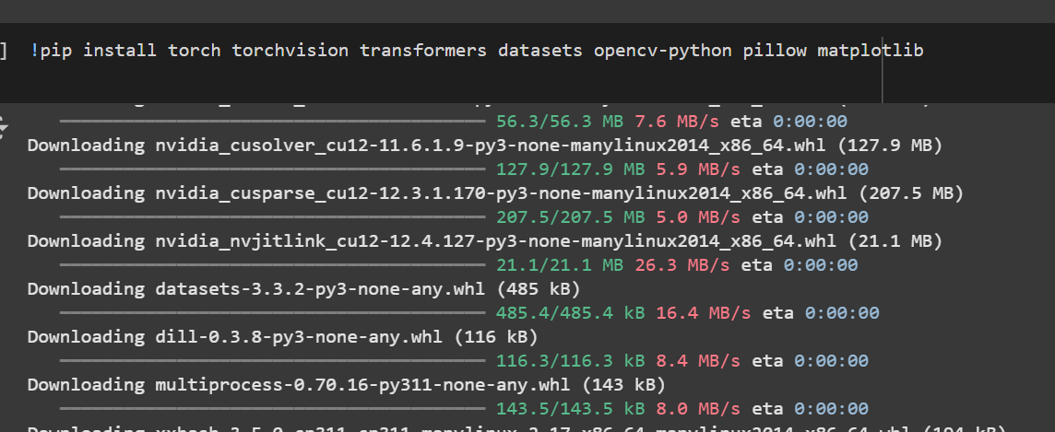

**Data Load:**

**Pre-Processing( Filtration and Mapping):**

**Pre-Trained Model:**

**Training Parameters:**

**Model Training:**

**Model Evaluation:**

**Inference on real and spoofed Image:**

**Part2: AI-Powered Visual Search (CLIP)**

Install Required Libraries:

* !pip install clip
* !pip install git+https://github.com/openai/CLIP.git

**Download the COCO Dataset**

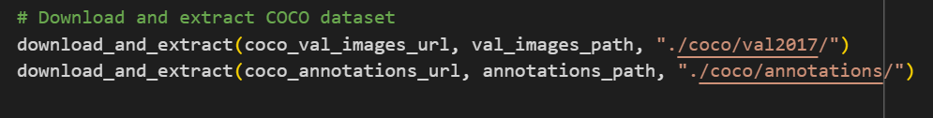

**Load the CLIP-ViT Model**

**Load COCO Annotations**

**Encode Images and Text Using CLIP**

**Retrieve Top-5 Similar Images for a Query**

Displaying retrieved Images:

**Part 3: Stable Diffusion**

**Load pre-Trained model:  
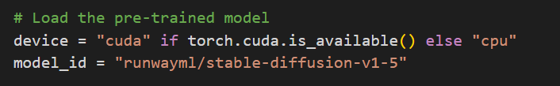**

**For Generating Image variations:**

**Experiment with different Parameters**

1. **strength**
   * Controls the level of transformation applied to an input image (if using img2img).
   * **Lower values (~0.5):** Preserve more of the original image.
   * **Higher values (~0.9):** Generate a more diverse or abstract image.
2. **guidance scale**
   * Determines how closely the model follows the text prompt.
   * **Lower values (~5.0):** More creative but may not match the prompt closely.
   * **Higher values (~12.0):** More aligned with the prompt but may lose artistic diversity.
3. **Num inference steps**
   * Defines how many steps the model takes to refine the image.
   * **Fewer steps (~20):** Faster generation, but lower quality.
   * **More steps (~50):** Higher detail and realism, but slower processing.

**Effects of Changes:**

* If **strength** is **low**, the original image (if provided) is more recognizable.
* If **guidance scale** is **high**, the model sticks strictly to the given prompt, reducing randomness.
* If **num inference steps** is **increased**, the output will be more refined, but with diminishing returns after ~50 steps.

From variation 1-3 the image becomes less defined and according to the prompt

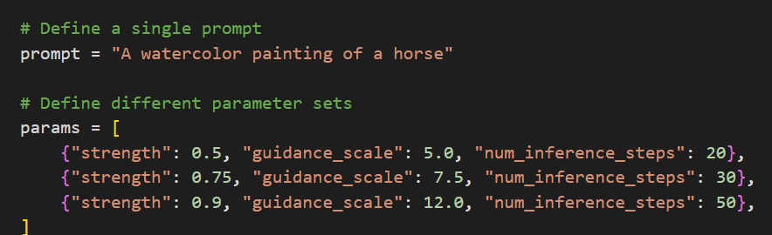

**Variation 1:**

**

**

**With Different Prompts:**

prompts = [

    "A watercolor painting of a horse",

    "A pixel art representation of a horse",

    "A surreal horse painting in the style of Salvador Dalí",

    "A horse painting in the style of Van Gogh",

    "A futuristic cyberpunk horse with neon lights"

]

